pr
Epic HAND-OUT 

Student /Instructor- Preceptor Cosign Process
Refresher 4/15/2022
Audience: Students, Instructors, and Preceptors
Review of the cosign workflow for students, preceptors, and instructors.
 | Let’s Take a Look

Student
Upon log in to Epic, students are present with a screen to select default co-signer. This co-signer is used for all flowsheet and MAR documentation.
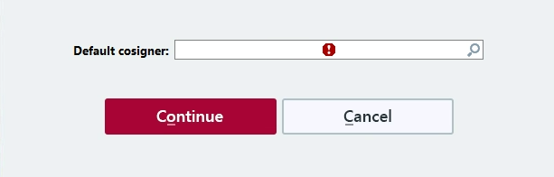

In flowsheet activity, if the default co-signer needs to be changed, use the icon “Responsible”

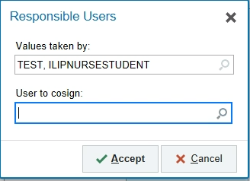

After completing documentation, click Pend, in the upper left corner.
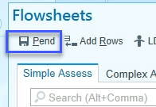
MAR documentation
When administering medications, the default co-signer auto-populates.
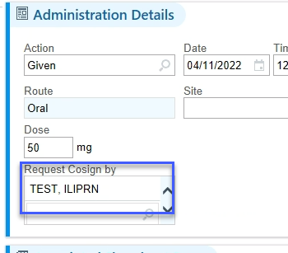

The co-signer can be changed, by deleting and entering correct name.

To change to default co-signer for multiple medications, click the Cosigner button.
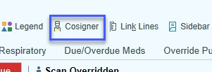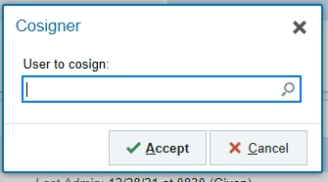

Note creation
Notes authored by students, also require a co-sign. The default co-signer does not populate and must be entered each time.
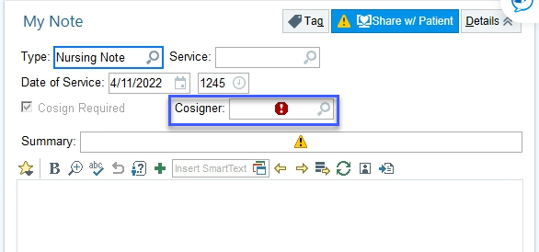

instructor- Preceptor
First option for cosigning:
Patient list reports contains a report entitled Nursing Clinical Links.
Contained in this report, are 2 additional reports:
Flowsheet needing cosign-allows for cosigning of flowsheet documentation only.
Needs Cosign-allows cosigning of both MAR administrations and flowsheet documentation

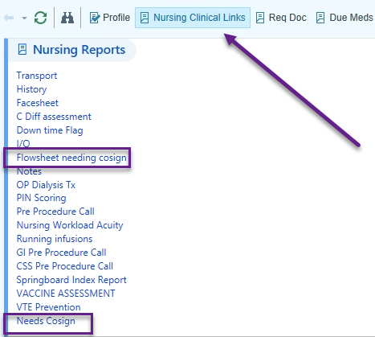
In Patient List, there are also three columns that can be added to identify which patients have documentation to cosign and what type of documentation.
- Flowsheet Requires My cosign
- Med Admin Cosign Needed?
- My Cosign Notes

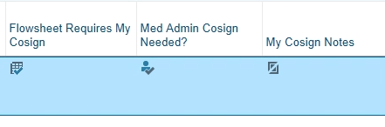
Second option for cosigning:
After access a patient’s chart, an instructor/preceptor can view medication administrations that need co-signing from the Summary activity Overview report. Report has same functionality as the Needs Cosign report in the clinical links report
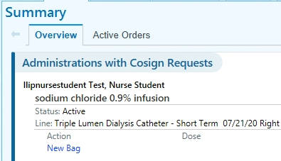

For flowsheet documentation, open Flowsheet activity, a Cosign Report icon displays.
Click to open and options for cosigning are in this report.

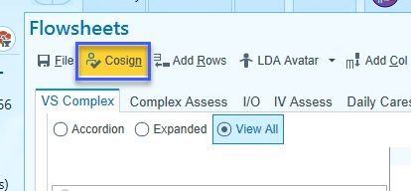

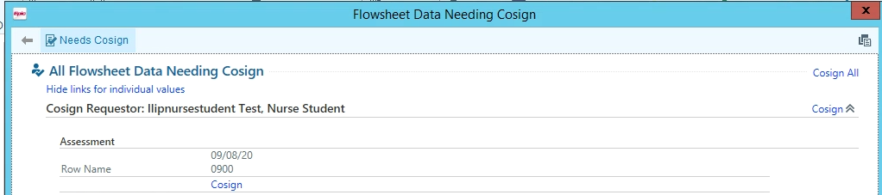

Notes that need co-signed
In InBasket activity, only notes can be cosigned.

NOTE: NO, other documentation is accessible here.

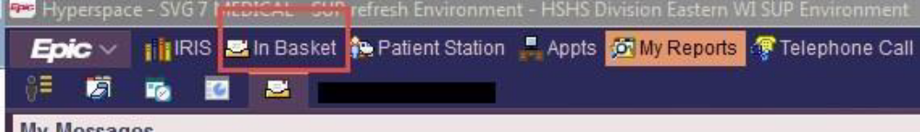

Click on the Cosign Notes folder.
Result - the notes requiring cosign display to the right.
Highlight the note to review.
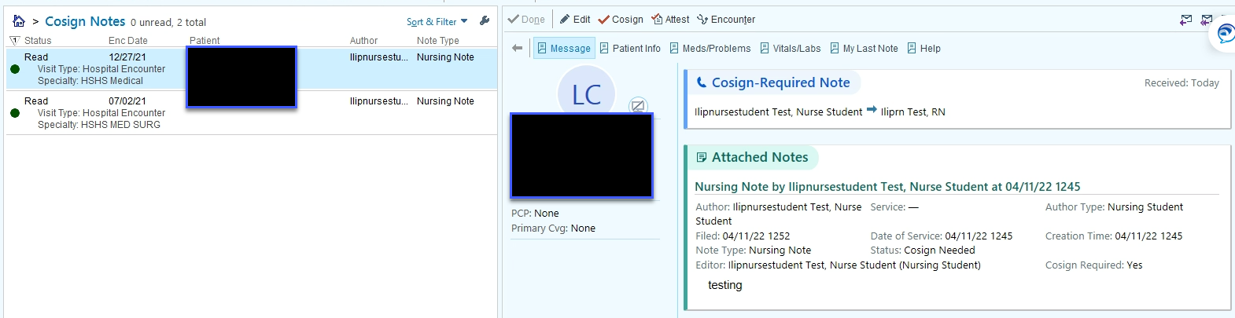

To add information to the note, click Edit.
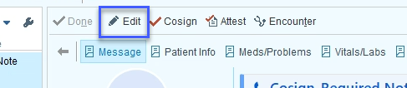

Complete Edit and click Sign
